**A preliminary examination of language attitudes among learners of French in higher education: Toward greater awareness and appreciation of diversity**

Dear participant,

Thank you for your interest in my study on the different accents of French!

My name is Marie-Eve Bouchard, I am an assistant professor of sociolinguistics in the Department of French, Hispanic and Italian Studies at UBC, and I am the main investigator for this research project.

To participate in this study, you will need a computer with a stable Internet connection and headphones to listen careful to audio recordings.

For this experiment, you will listen to ten young women speaking in French. After each recording, you will answer a few questions regarding the speaker and their accent. If necessary, you can listen to the recording twice. The experiment should last around 30 minutes – but you can take as long as you want.

The first recording will serve as practice – the objective is to get familiarized with the task. This recording will not be included in the results.

Before the recordings, you will be invited to answer a few questions that will allow me to know more about you as a learner of French.

Please, do not hesitate to contact me if you have any questions: [me.bouchard@ubc.ca](mailto:me.bouchard@ubc.ca)

Your participation is important to the realisation of this research project. I thank you deeply for you time and responses.

**INFORMATION AND CONSENT FORM**

**Project title**:Follow up on: A preliminary examination of language attitudes among learners of French in higher education

**Consent form online**: This study is conducted by Prof. Marie-Eve Bouchard, who is an Assistant Professor in the Department of French, Hispanic and Italian Studies at UBC ([me.bouchard@ubc.ca](mailto:me.bouchard@ubc.ca)). Her research assistant, Rachel Chen, is an undergraduate student in in the Department of French, Hispanic and Italian Studies at UBC. Ethics ID number: H22-01410.

**Research objective**: The objective of this research is to evaluate different accents of French. To reach this objective, I need the participation of as many French learners at UBC as possible in order to include the opinions of people coming from all around the world.

**What is the procedure of this study?** This study is conducted online. As a participant of the study, you will answer an online questionnaire about different varieties of French. The time necessary to complete this questionnaire is around 30 minutes.

**Are there any potential risks associated to the study?** There are no anticipated risks associated with the participation of this study.

**Are there any potential benefits to participating in this study?** There are no benefits associated with your participation to this research. For you, participation to this study could be perceived as an opportunity to listen to and familiarize yourself with different accents of French. Research-wise, your participation will allow me to learn more about French learners’ perceptions of different accents.

**Data processing and anonymity**. I am interest in your linguistic profile, but I will not ask you any personal information that would allow someone to identify you (e.g., full name, address, phone number). However, you will have the possibility to give your email address to be eligible to win a gift card from the UBC Bookstore. Your answers to this questionnaire will be anonymized and saved on a secured server from the UBC Arts Faculty. Data will only be accessible to the principal investigator and her research assistants. Data will be kept for at least 5 years.

**Voluntary participation**. Your participation to this study is voluntary. You can withdraw from the study at any time without consequences and without having to give any justification. Your withdrawing from the study will not bring any inconvenience.

**Study’s results**. The main results will be published Open Access in scientific journals and presented at scholarly conferences. If you want more information about the results, please contact me (Marie-Eve Bouchard) at this email address: [me.bouchard.@ubc.ca](mailto:me.bouchard.@ubc.ca)

**Contact details and questions**. If you have any concerns or complaints about your rights as a research participant and/or your experiences while participating in this study, contact the Research Participant Complaint Line in the UBC Office of Research Ethics at 604-822-8598 or if long distance e-mail RSIL@ors.ubc.ca or call toll free 1-877-822-8598.

**The participant’s declaration of consent**. By clicking on the button “I consent”, you acknowledge that you have read and understood the consent form and that you consent to participate to this student.

I CONSENT.

PART 1: SOCIODEMOGRAPHIC AND LINGUISTICS QUESTIONS

1. To which gender to you identify?

- women

- men

- prefer not to answer

- prefer to define myself: ___________

2. How old are you?

3. In what country were you born? If it’s in Canada, in what province or territory?

4. In what city, town or village have you grown up? (More than one answer is possible.)

5. What is your field of studies?

6. To which racial or ethnic group do you consider yourself to belong?

- White

- Black

- South Asian (e.g., East Indian, Pakistani, Sri Lankan, etc.)

- Chinese

- Filipino

- Latin American

- Arab

- Southeast Asian (e.g., Vietnamese, Cambodian, Laotian, Thai, etc.)

- West Asian (e.g., Iranian, Afghan, etc.)

- Korean

- Japanese

- Indigenous

- Other - specify: ____________

- I prefer not to answer

7. How many languages do you speak? Which ones?

8. What is your first language? Or what are your first languages?

9. For how many years have you been studying French?

10. Have you lived or spent time in Quebec, France, or in another French-speaking country? If so, for how many months?

11. What French accent would you prefer to learn?

- Quebec French

- France French

- other variety of French (specify): _______________

12. Your French teacher(s) are/were mainly of what origin?

- French

- Quebec

- other (specify): ___________________

PART 2: EVALUATING DIFFERENT ACCENTS

The French speakers who recorded the audios had one task: describe an image. Here is the image that all participants have described:

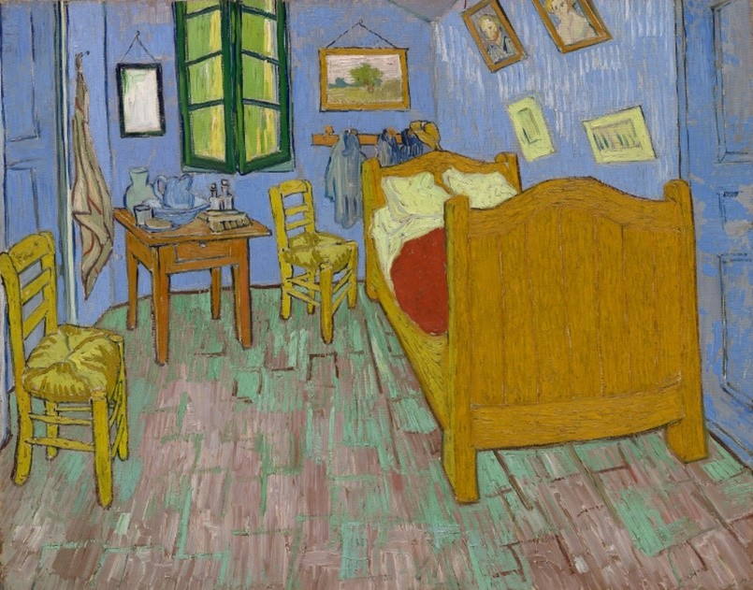

The two following recordings will serve as a practice. Listen to the recording, adjust the volume, and for each recording, answer the following questions in order to familiarize with the task.

QUESTIONS.(Participants will answer with a 6-point Likert scale.)

**Do you agree or disagree with the following statements and questions? Rate from 1 (I strongly disagree) to 6 (I strongly agree).**

1) I think this is beautiful French.

2) This speaker is easy to understand.

3) Would the person who did the recording be a good French teacher at UBC?

4) The speaker has a nice accent.

5) This person is dynamic.

6) This person is nice.

7) This person is social.

8) This person is professional.

8) This person is leader.

10) This person is educated.

**Where do you think this person is from?** _________________

Scales :

1. I strongly disagree
2. I disagree
3. I slightly disagree
4. I slightly agree
5. I agree
6. I strongly agree

The pictures will be randomized. Here are the pictures the participants will see.

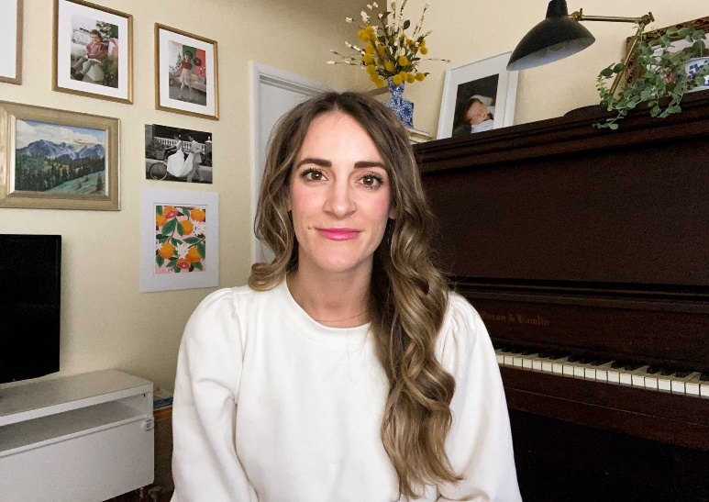

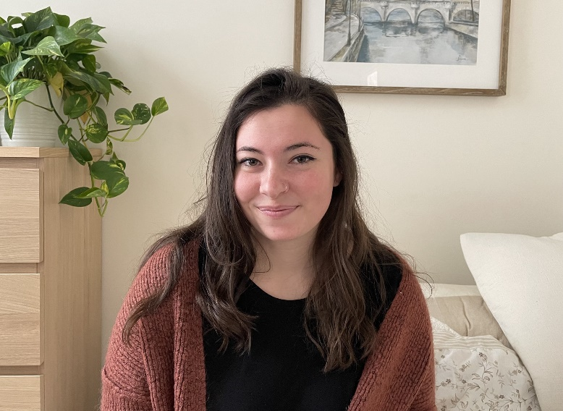

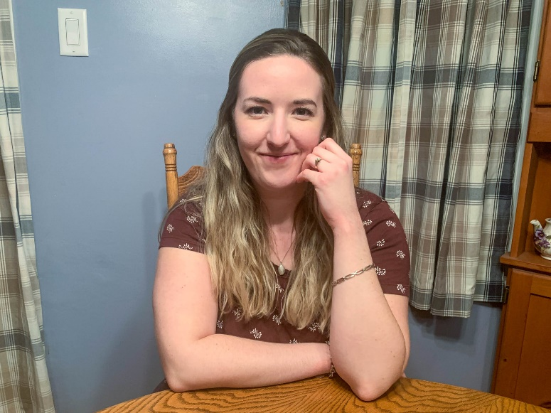

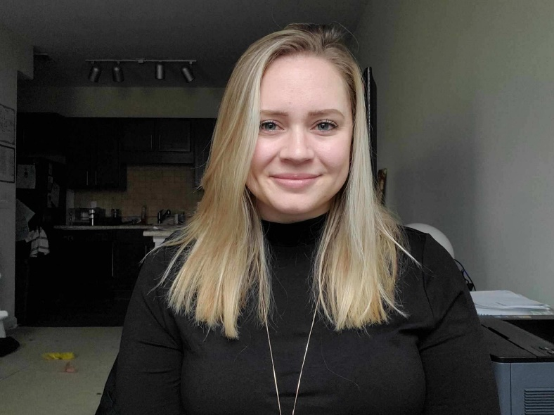



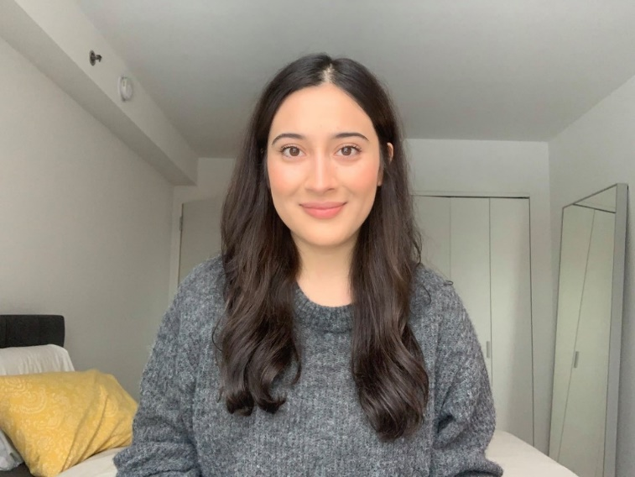

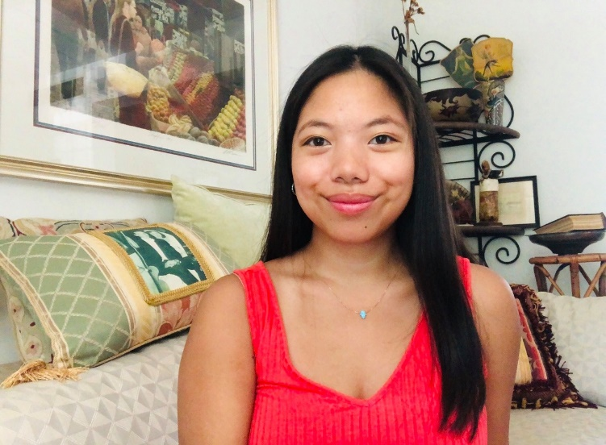

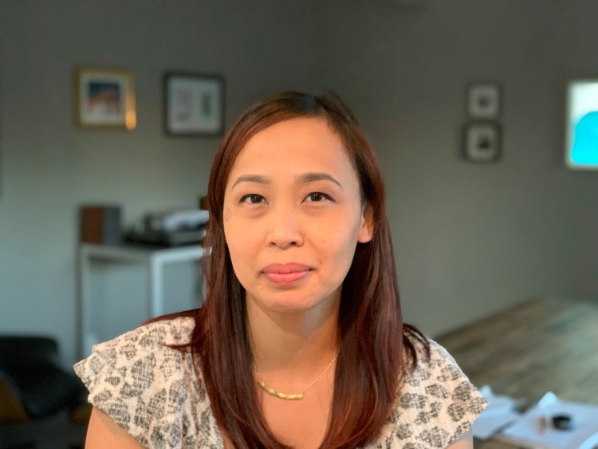

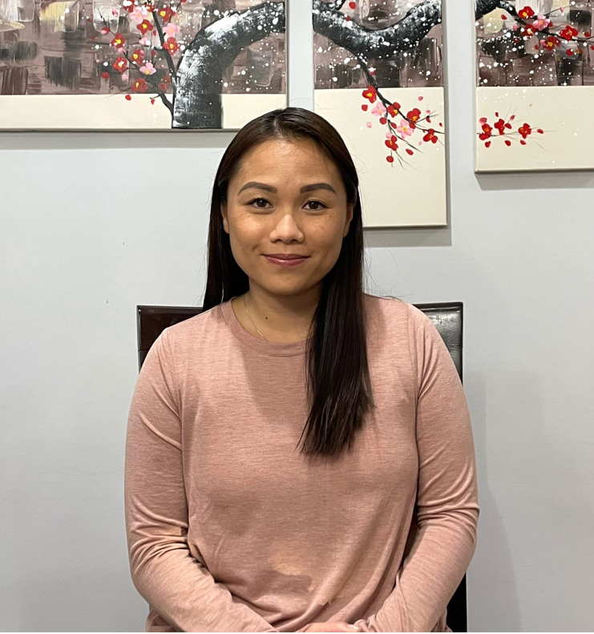

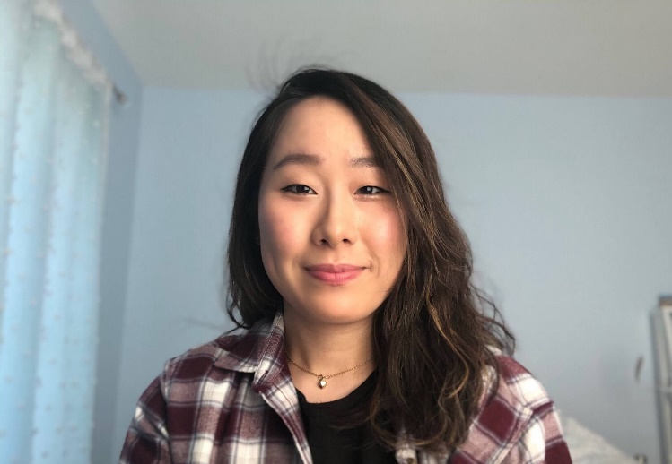

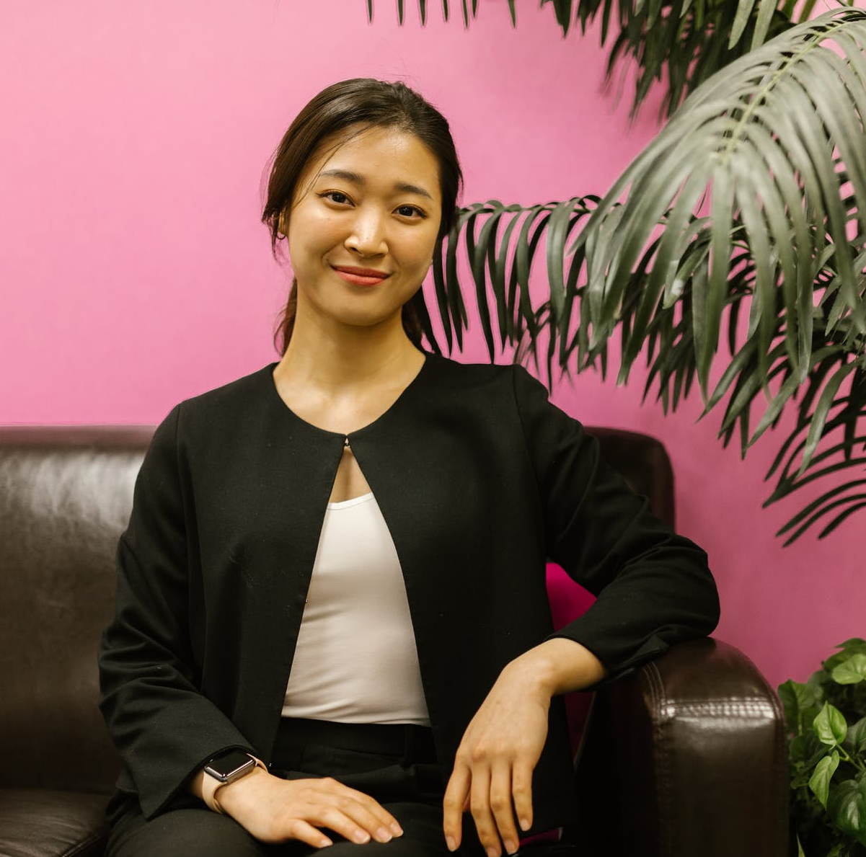

To be eligible to win one $100 gift certificate from the UBC Bookstore, add your e-mail address here: _______________________________.